**PROJECT ORION**

**TEAM ECHELON**

**Ahmet NAsuhcan ÜNLÜ|İlker mavİlİ |Ozan İrfan BAYAR**

SYSTEM REQUIREMENTS

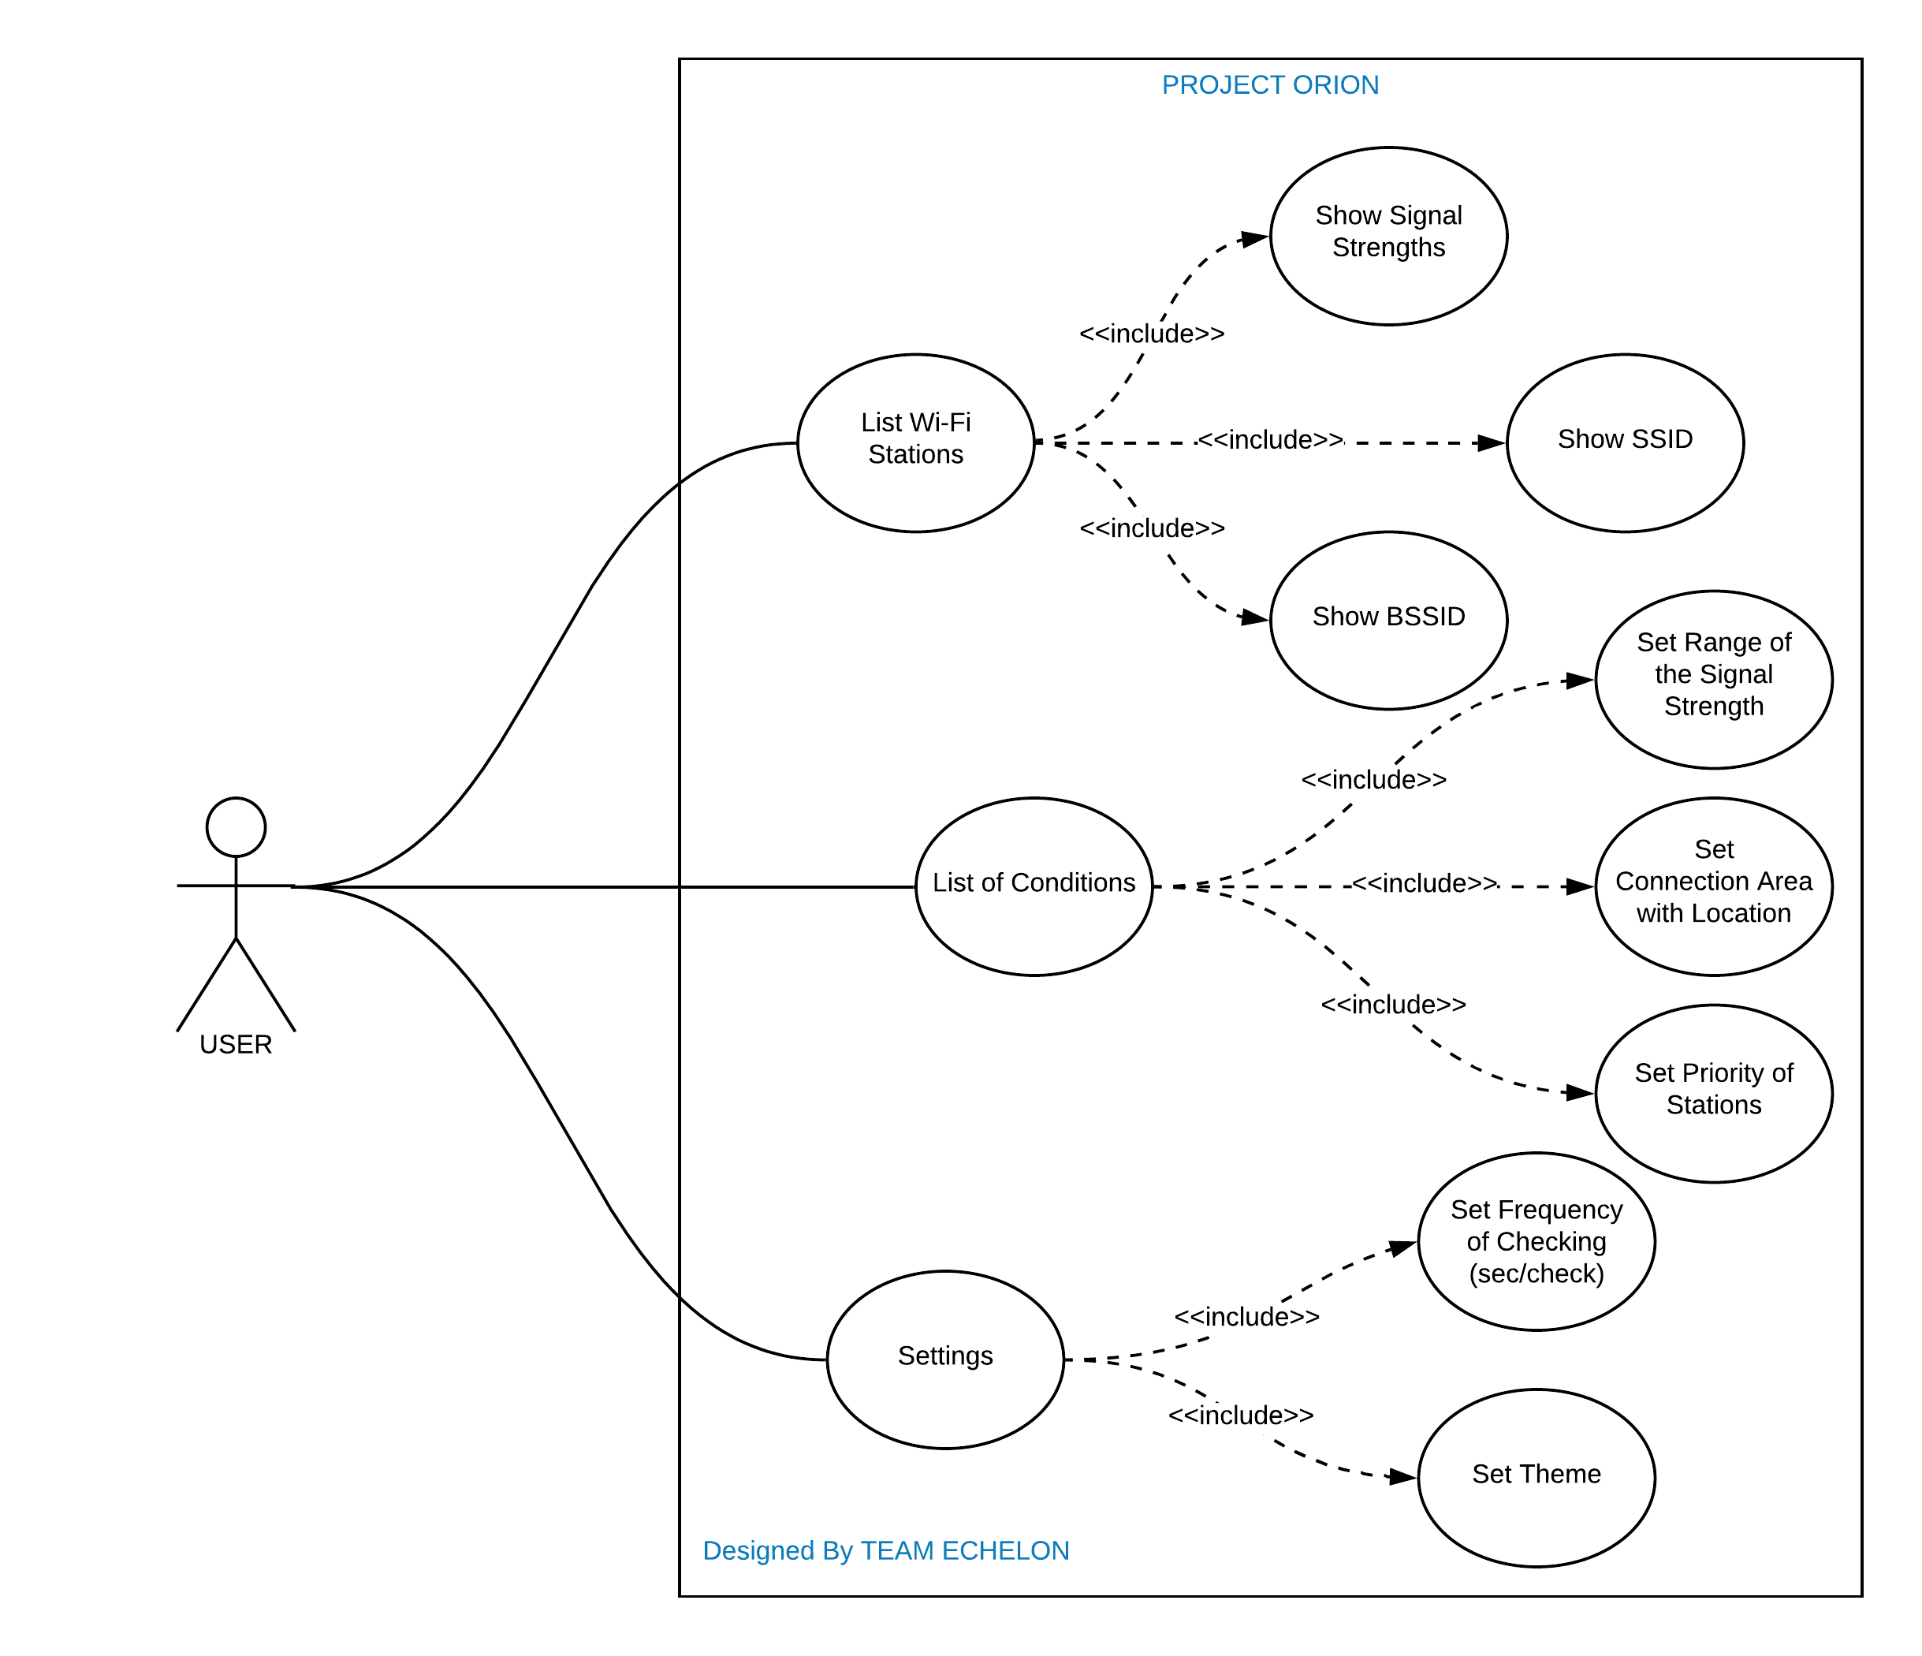

**USER 1: ⭐️⭐️⭐️⭐️⭐️**

I am a developer and I live in a big flat. My working space is at the furthest point to the router. For that reason, I am using my old router as an access point but when I go to my room, my phone does not switch automatically to the Wi-Fi which has the strongest signal. I can set the range of signal strength and I do not need to make an intervention thanks to the Orion.

**USER 2: ⭐️⭐️⭐️⭐️**

I am a student and have to stay in a dormitory. The dormitory does not have a good wireless technology, there are separate Wi-Fi for each floor but we are not able to connect automatically to the nearest Wi-Fi. And that causes increase of the signal attenuation. To handle this issue, I recommend Orion app to my dormitory friends.

**USER 3:** **⭐️⭐️⭐️⭐️⭐️**

There are two access points in my office that placed in different points, but I cannot switch Wi-Fi automatically. I do many phone calls due to my job and need to use my battery efficiently too. I have used many apps to solve this but they drain the battery too fast. Orion has an option which allows setting the checking frequency to reduce battery consumption. That’s why I am using it and recommend to everyone in my office.

**USER 4: ⭐️⭐️⭐️⭐️⭐️**

I was working in a big company, but I have to work at home now due to Covid-19. I bought an access point to place it in ground floor because I want to use my computer in my garden while working. The connection strength is getting weak when I go to the downstairs during the work. That’s why I need an application like Orion. It changes the Wi-Fi networks instantly according to the signal power.